**Update Account ID**

Sample Ticket:- 270671933

1. The ticket should be validated to verify that the issue is relevant to BBW.

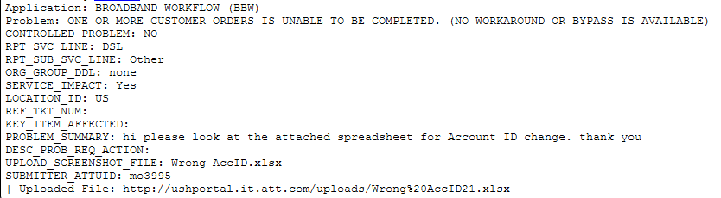

Here, Application, RPT_SVC_LINE and PROBLEM_SUMMARY fields help in determining the nature of ticket. In BBW all the relevant tickets will have their RPT_SVC_LINE as DSL. If you receive it as something else then either it is a user’s mistake or the ticket probably does not correspond to BBW, although checking once with user is advised before closing ticket just based on these factors.

Opening the attached spreadsheet you will find further details where updates are needed to be performed.



Here the mentioned BBW case 6584010 has incorrect Sub Account number updated for it in BBW DB and it needs to be updated to the correct SA number. The required details are provided by the user in the attachment listed in the ticket itself.

Such as scenario is reported by the user and needs DB updates to be made manually.

1. Since the SIID has been provided by the user, it can be used to check and update the required fields.

The following query should be used to determine the customer_account2site field in DB

select site_id, customer_account2site, billing_account_number from table_customer_account where site_id='837515'



Re-check the details using the select query to double check.

select site_id, customer_account2site, billing_account_number from table_customer_account where CUSTOMER_ACCOUNT2SITE='269514374'

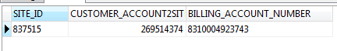

Now, using the provided details from user update the correct SA number in the billing_account_number field

update table_customer_account set BILLING_ACCOUNT_NUMBER ='8310005063108' where CUSTOMER_ACCOUNT2SITE='269514374'



Now, to validate the update at your own end execute the select query once again.

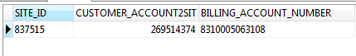

As visible the correct data has been updated.

1. Once the necessary updates have been completed, update the USH with appropriate details.
2. Intimate the user for validation
3. After validation has been completed, proceed to set the ticket to RTC.